**Project Report**

**Desktop GUI Application**

**Topic: ONLINE VOTING SYSTEM**

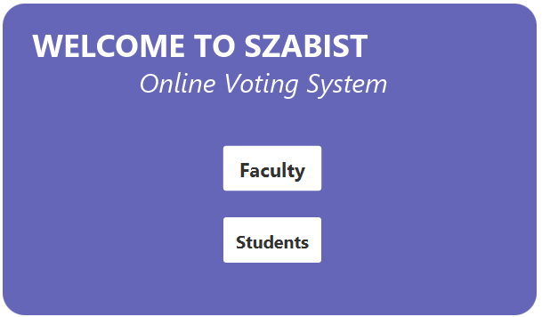

**Application Introduction**:

* **Our OOPs project is Desktop Application.**
* **Topic: SZABIST ONLINE VOTING SYSTEM.**
* **We make application on intelij with jdk 17.**
* **In the making of this application we use java with oops.**
* **The website main purpose to make voting system easier.**
* **Our website consists of 4 pages.**
* **1ST page is the Home page, consists 2 button which ask you that is you are from faculty or a student?**
* **2ND page is the login form which record that who is voting.**
* **3RD page is the voting panel; after login you can select candidate of your own choice to vote, it also allow faculty members to see the winning candidate.**
* **4TH page is the last page which insure that you vote is listed with a good bye msg.**

**Application Page No.1**

**Home Page.**



**APPLICATION PAGE No.2**

**Login Page.**



**Application Page No.3**

**Voting Panel**

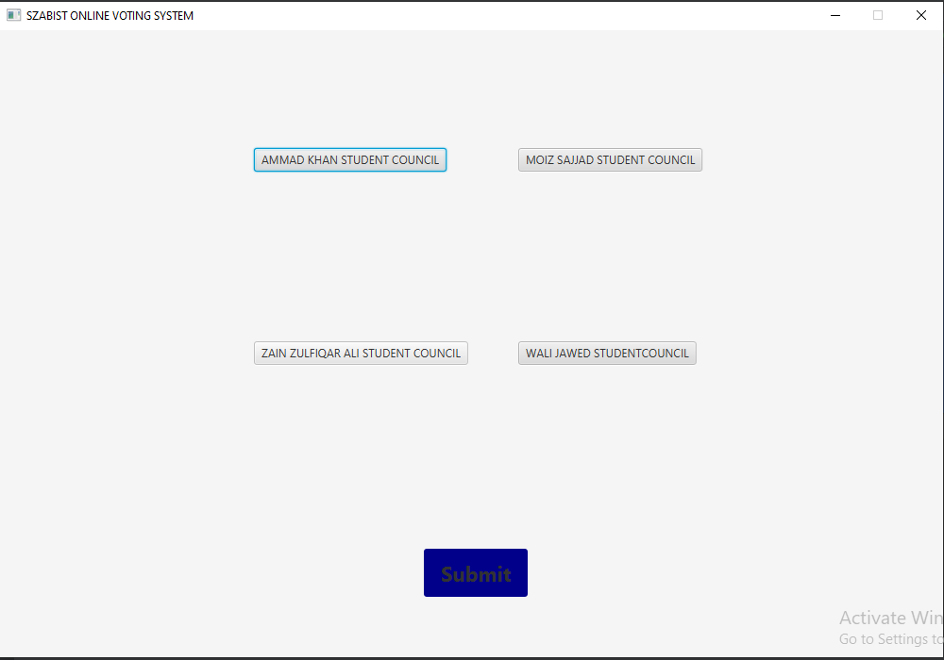

**Application Page No.4**

**Voting confirm Page**

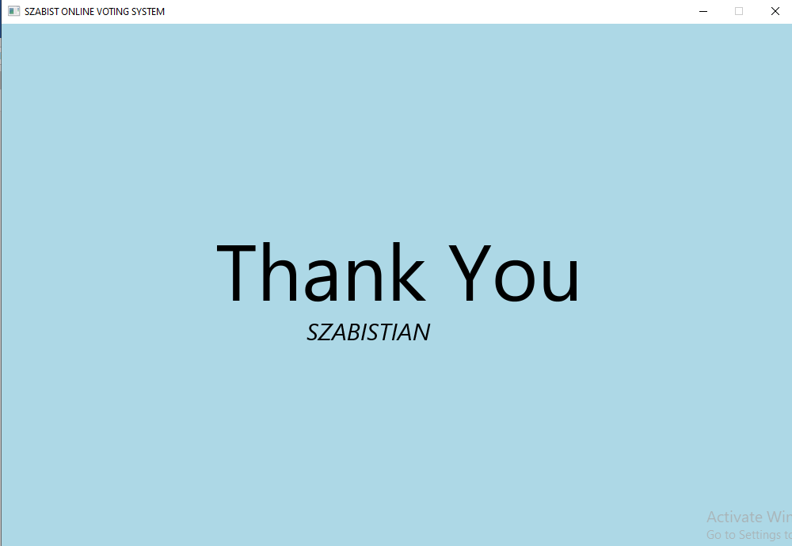

**CODE:**

package com.example.demo;  
  
import static javafx.scene.text.TextAlignment.*CENTER*;  
import javafx.application.Application;  
import javafx.geometry.Pos;  
import javafx.scene.Group;  
import javafx.scene.Scene;  
import javafx.scene.control.Button;  
import javafx.scene.control.PasswordField;  
import javafx.scene.control.TextField;  
import javafx.scene.paint.Color;  
import javafx.scene.shape.Rectangle;  
import javafx.scene.text.Font;  
import javafx.scene.text.FontPosture;  
import javafx.scene.text.FontWeight;  
import javafx.scene.text.Text;  
import javafx.stage.Stage;  
  
import java.io.FileWriter;  
import java.io.IOException;  
  
public class Main extends Application {

// File path to store the vote results  
 private static final String *FILE_PATH* = "vote_results.txt";  
  
 // Vote counts for each candidate  
 private int ammadVotes = 0;  
 private int moizVotes = 0;  
 private int zainVotes = 0;  
 private int waliVotes = 0;  
  
 public void start(Stage stage) throws Exception {  
 Scene scene1, scene2, scene3, scene4, scene41, scene5;//************************ Home Page Coding  
  
  
  
 Rectangle r1 = new Rectangle();  
 r1.setX(202);  
 r1.setY(160);  
 r1.setWidth(600);  
 r1.setHeight(350);  
 r1.setArcWidth(50);  
 r1.setArcHeight(50);  
 r1.setFill(Color.*DARKBLUE*);  
 r1.setOpacity(0.6);  
  
 Text t=new Text("WELCOME TO SZABIST");  
 t.setLayoutX(235);  
 t.setLayoutY(220);  
 t.setTextAlignment(*CENTER*);  
 t.setFill(Color.*WHITE*);  
 t.setFont(Font.*font*("Archive", FontWeight.*BOLD*,35));

Text t1=new Text("Online Voting System");  
 t1.setLayoutX(355);  
 t1.setLayoutY(260);  
 t1.setTextAlignment(*CENTER*);  
 t1.setFill(Color.*WHITE*);  
 t1.setFont(Font.*font*("Archive", FontWeight.*THIN*, FontPosture.*ITALIC*,30));

Button b=new Button("Faculty");  
 b.setStyle("-fx-background-color: white; -fx-textfill: white");  
 b.setFont(Font.*font*("Archive", FontWeight.*BOLD*,22));  
 b.setTextAlignment(*CENTER*);  
 b.setLayoutX(450);  
 b.setLayoutY(320);  
 b.setAlignment(Pos.*BOTTOM_CENTER*);  
 b.setPrefSize(110,50);  
 Button b1=new Button("Students");  
 b1.setStyle("-fx-background-color: white; -fx-textfill: white; ");  
 b1.setFont(Font.*font*("Archive", FontWeight.*BOLD*,19.7));  
 b1.setTextAlignment(*CENTER*); b1.setLayoutX(450); b1.setLayoutY(400);  
 b1.setAlignment(Pos.*BOTTOM_CENTER*); b1.setPrefSize(110,50);  
  
 Group root1 = new Group(r1,t,t1,b,b1); scene1 = new Scene(root1, 1000, 665);

//************************* Faculty Login Page Coding*************************  
  
 Rectangle r2 = new Rectangle();  
 r2.setWidth(500);  
 r2.setHeight(665);  
 r2.setFill(Color.*DARKBLUE*);  
 r2.setOpacity(0.8);  
 Text txt=new Text("ONLINE VOTING\nSYSTEM");  
 txt.setLayoutX(65);  
 txt.setLayoutY(90);  
 txt.setTextAlignment(*CENTER*);  
 txt.setFont(Font.*font*("Verdana", FontWeight.*BOLD*,40));  
 txt.setFill(Color.*WHITE*);  
 Text txt1=new Text("Become a part\n of the Szabist University\n " +  
 "Voting Community,\n and select your\n Student Council\n Leaders");  
 txt1.setLayoutX(60);  
 txt1.setLayoutY(250);  
 txt1.setTextAlignment(*CENTER*);  
 txt1.setFont(Font.*font*("Archive", FontWeight.*THIN*, FontPosture.*ITALIC*,40));  
 txt1.setLineSpacing(2); txt1.setFill(Color.*WHITE*);  
 TextField userNameField2 = new TextField();  
 userNameField2.setLayoutX(645);  
 userNameField2.setLayoutY(220);  
 userNameField2.setPrefSize(215, 50);  
 userNameField2.setFont(Font.*font*("Open Sans Light",FontWeight.*THIN*,20));  
 userNameField2.setPromptText("Name");  
 PasswordField userPasswordField2 = new PasswordField();  
 userPasswordField2.setLayoutX(645);  
 userPasswordField2.setLayoutY(310);  
 userPasswordField2.setPrefSize(215, 50);  
 userPasswordField2.setFont(Font.*font*("Open Sans Light",FontWeight.*THIN*,20));  
 userPasswordField2.setPromptText("Password");  
 Button btn2 = new Button("Login");  
 btn2.setLayoutX(705);  
 btn2.setLayoutY(450);  
 btn2.setPrefSize(100,40);  
 btn2.setStyle("-fx-background-color: darkblue; -fx-textfill: white");  
 btn2.setFont(Font.*font*("Archive", FontWeight.*BOLD*,20)); btn2.setOpacity(0.9);  
 Group root2 = new Group(r2, txt,txt1,btn2,userNameField2,userPasswordField2);  
 scene2 = new Scene(root2, 1000, 665);

//************************* Student Login Page Coding*************************/  
  
 Rectangle r3 = new Rectangle();  
 r3.setWidth(500);  
 r3.setHeight(665);  
 r3.setFill(Color.*DARKBLUE*);  
 r3.setOpacity(0.9);  
 Text txt3=new Text("ONLINE VOTING\nSYSTEM");  
 txt3.setLayoutX(65);  
  
 txt3.setLayoutY(90);  
 txt3.setTextAlignment(*CENTER*);  
 txt3.setFont(Font.*font*("Verdana", FontWeight.*BOLD*,40));  
 txt3.setFill(Color.*WHITE*);  
 Text txt4=new Text("Become a part\n of the Szabist University\n Voting Community,\n and select your\n Student Council\n Leaders"); txt4.setLayoutX(60); txt4.setLayoutY(250); txt4.setTextAlignment(*CENTER*);  
 txt4.setFont(Font.*font*("Archive", FontWeight.*THIN*, FontPosture.*ITALIC*,40));  
 txt4.setLineSpacing(2);  
 txt4.setFill(Color.*WHITE*);  
  
 TextField userNameField3 = new TextField();  
 userNameField3.setLayoutX(645);  
 userNameField3.setLayoutY(220);  
 userNameField3.setPrefSize(215, 50);  
 userNameField3.setFont(Font.*font*("Open Sans Light",FontWeight.*THIN*,20));  
 userNameField3.setPromptText("Name");  
 PasswordField userPasswordField3 = new PasswordField();  
 userPasswordField3.setLayoutX(645);  
 userPasswordField3.setLayoutY(310);  
 userPasswordField3.setPrefSize(215, 50);  
  
 userPasswordField3.setFont(Font.*font*("Open Sans Light",FontWeight.*THIN*,20));  
 userPasswordField3.setPromptText("Password");  
 Button btn3 = new Button("Login");  
 btn3.setLayoutX(705);  
 btn3.setLayoutY(450);  
 btn3.setPrefSize(100,40);  
 btn3.setStyle("-fx-background-color: darkblue; -fx-textfill: white");  
 btn3.setFont(Font.*font*("Archive", FontWeight.*BOLD*,20)); btn3.setOpacity(0.9);  
 Group root3 = new Group(r3, txt3,txt4,btn3,userNameField3,userPasswordField3);  
 scene3 = new Scene(root3, 1000, 665);  
  
  
  
 //************************* Faculty Voting Page Coding*************************/  
  
  
  
// vote image 1  
  
 Button votef1=new Button("AMMAD KHAN STUDENT COUNCIL");  
 votef1.setTranslateX(270);  
 votef1.setTranslateY(125);  
  
//vote image 2  
 Button votef2=new Button("MOIZ SAJJAD STUDENT COUNCIL");  
 votef2.setTranslateX(550);  
 votef2.setTranslateY(125);  
  
//vote image 3  
 Button votef3=new Button("ZAIN ZULFIQAR ALI STUDENT COUNCIL");  
 votef3.setTranslateX(270);  
 votef3.setTranslateY(330);  
  
//vote image 4  
 Button votef4=new Button("WALI JAWED STUDENTCOUNCIL");  
 votef4.setTranslateX(550);  
 votef4.setTranslateY(330);  
  
 //submit button  
 Button fsubmit=new Button("Submit");  
 fsubmit.setStyle("-fx-background-color: darkblue; -fx- text-fill: white");  
 fsubmit.setFont(Font.*font*("Archive",  
 FontWeight.*BOLD*,22));  
 fsubmit.setTextAlignment(*CENTER*);  
 fsubmit.setLayoutX(450);  
 fsubmit.setLayoutY(550);  
 fsubmit.setAlignment(Pos.*BOTTOM_CENTER*);  
 fsubmit.setPrefSize(110,50);  
  
 Group root4 = new Group (votef1, votef2,  
 votef3,votef4, fsubmit);  
 scene4 = new Scene(root4, 1000,  
 665,Color.*WHITESMOKE*);  
  
//******************** Student Voting Page Coding*********************/  
  
  
  
// vote image 1  
 Button votef12=new Button("AMMAD KHAN STUDENT COUNCIL");  
 votef12.setTranslateX(270); votef12.setTranslateY(125);

//vote image 2  
 Button votef22=new Button("MOIZ SAJJAD STUDENT COUNCIL");  
 votef22.setTranslateX(550); votef22.setTranslateY(125); //vote image 3  
 Button votef32=new Button("ZAIN ZULFIQAR STUDENT COUNCIL");  
 votef32.setTranslateX(270); votef32.setTranslateY(330);  
  
//vote image 4  
 Button votef42=new Button("WALI JAWED STUDENT COUNCIL");  
 votef42.setTranslateX(550); votef42.setTranslateY(330);

//submit button  
 Button ssubmit=new Button("Submit");  
 ssubmit.setStyle("-fx-background-color: darkblue; -fx- text-fill: white");  
 ssubmit.setFont(Font.*font*("Archive",  
 FontWeight.*BOLD*,22));  
 ssubmit.setTextAlignment(*CENTER*);  
 ssubmit.setLayoutX(450);  
 ssubmit.setLayoutY(550);  
 ssubmit.setAlignment(Pos.*BOTTOM_CENTER*);  
 ssubmit.setPrefSize(110,50);  
  
 Group root41 = new Group(votef12, votef22,  
 votef32,votef42, ssubmit); scene41 = new Scene(root41,1000,

665,Color.*WHITESMOKE*);  
 //************************* Last Page Coding*************************/  
  
  
 Text t2=new Text("Thank You");  
 t2.setLayoutX(270);  
 t2.setLayoutY(350);  
 t2.setTextAlignment(*CENTER*);  
 t2.setFill(Color.*BLACK*);  
 t2.setFont(Font.*font*("Archive",100));  
  
 Text t3=new Text("SZABISTIAN");  
 t3.setLayoutX(385);  
 t3.setLayoutY(400);  
 t3.setTextAlignment(*CENTER*);  
 t3.setFill(Color.*BLACK*);  
 t3.setFont(Font.*font*("Archive", FontWeight.*THIN*,  
 FontPosture.*ITALIC*,30));  
  
 Group root5 = new Group(t2,t3);  
 scene5 = new Scene(root5, 1000, 665,Color.*LIGHTBLUE*);

//************************* Event Handling Coding*************************/  
  
 b.setOnAction(e -> stage.setScene(scene2)); //Faculty Page Button  
 b1.setOnAction(e -> stage.setScene(scene3));  
//Student Page Button  
 btn2.setOnAction(e -> stage.setScene(scene4));  
//Faculty Login Button  
 btn3.setOnAction(e -> stage.setScene(scene41));  
//Student Login Button  
 fsubmit.setOnAction(e -> stage.setScene(scene5));  
//Faculty Vote Submit Button  
 ssubmit.setOnAction(e -> stage.setScene(scene5));  
//Student Vote Submit Button  
  
  
 //*************************Stage Show Coding*************************/  
 stage.setResizable(false);  
 stage.setTitle("SZABIST ONLINE VOTING SYSTEM"); stage.setScene(scene1); stage.show();  
  
 stage.setResizable(false);  
 stage.setTitle("SZABIST ONLINE VOTING SYSTEM");  
 stage.setScene(scene1);  
 stage.show();  
}  
  
 private void showVoteResults() {  
 String winner = "";  
 int maxVotes = 0;  
  
 if (ammadVotes > maxVotes) {  
 maxVotes = ammadVotes;  
 winner = "ammad Student Council";  
 }  
 if (moizVotes > maxVotes) {  
 maxVotes = moizVotes;  
 winner = "moiz Majid Student Council";  
 }  
 if (zainVotes > maxVotes) {  
 maxVotes = zainVotes;  
 winner = "ZAIN ZULFIQAR Student Council";  
 }  
 if (waliVotes > maxVotes) {  
 maxVotes = waliVotes;  
 winner = "Wali Jawed Student Council";  
 }  
  
 System.*out*.println("Candidate with the most votes: " + winner);  
  
 try {  
 FileWriter writer = new FileWriter(*FILE_PATH*);  
 writer.write("Vote Results:\n");  
 writer.write("Ammad khan Student Council: " + ammadVotes + " votes\n");  
 writer.write("moiz Majid Student Council: " + moizVotes + " votes\n");  
 writer.write("ZAIN ZULFIQARStudent Council: " + zainVotes + " votes\n");  
 writer.write("Wali Jawed Student Council: " + waliVotes + " votes\n");  
 writer.write("Winner: " + winner);  
 writer.close();  
 } catch (IOException e) {  
 e.printStackTrace();  
 }  
 }  
  
 public static void main(String[] args) {  
 *launch*(args);  
 }  
}

**NOTE:**

1. **Our Application code contain all the basic concept of OOPs.**

* **Encapsulation.**
* **Inheritance.**
* **Polymorphism**
* **Abstraction.**

1. **We have done file Handling in this code also.**
2. **You can also run this code by copping it on any IDE compiler which contain javafx library.**

